Problem Specification/Project Plan
Project Title: Practical Benchmarking of Approximate Machine Unlearning for Auditable Enterprise ML Erasure Workflows
Student Name: Niamh Hughes
Student ID: 40299386
Project Supervisor Name: Awais Rauf

- Introduction
  - Project Overview
This project builds and tests a reproducible benchmarking framework for approximate machine unlearning on tabular classification. Under the UK GDPR, simply deleting a record isn't enough if the trained model still reflects its influence. Full retraining removes that influence completely but is costly, while approximate methods are cheaper but their effectiveness and privacy properties aren't well understood for tabular data. This project compares Full Retraining, Retain-Set Fine-Tuning, Gradient Ascent Unlearning and SISA across three tabular datasets, each under two GDPR-motivated deletion scenarios, with the aim of producing a research artefact that supports companies in discussing auditable erasure workflows with enterprise clients.
1.2 Objectives
To investigate existing machine unlearning techniques and their role in supporting data deletion requirements within machine learning systems.
To implement and evaluate Full Retraining, Retain-Set Fine-Tuning, Gradient Ascent Unlearning and SISA on tabular classification models.
To assess the impact of each unlearning method on predictive performance using AUROC and F1 Score.
To evaluate the similarity of unlearned models to a fully retrained baseline using prediction agreement.
To assess the effectiveness of each method in reducing privacy leakage through Membership Inference Attacks (MIA).
To compare the computational efficiency of machine unlearning methods against full model retraining.
To analyse the trade-offs between utility, privacy preservation and computational cost across multiple datasets.
To base the two deletion scenarios on specific parts of GDPR: Article 17 (right to erasure) for the consent-withdrawal scenario, and Article 5(1)(e) (storage limitation) for the retention-expiry scenario.

- Problem Specification
2.1 Background and Context
As more sectors adopt machine learning, large volumes of personal data are being used to train predictive models. The UK GDPR places strict obligations on how this data is retained and deleted. Article 17 gives individuals the Right of Erasure under several legal grounds [19], and two of these map directly onto the deletion scenarios used in this project. Article 17(1)(b) covers withdrawal of consent: an individual can request deletion of their data at any time, regardless of how long it has been held. This is the basis for the consent-withdrawal forget set. Article 5(1)(e), the storage limitation principle, requires that personal data is kept "in a form which permits identification...for no longer than is necessary" [20]. There is no fixed time limit; instead, the controller must define and document a retention period appropriate to the purpose of the data, after which it becomes eligible for deletion regardless of whether anyone has requested it. This is the basis for the retention-expiry forget set, built using a simulated 'date captured' field (Section 3, Table 1). In both cases, deleting the raw record is not enough: if the trained model still reflects the influence of that record, it may still allow the individual to be re-identified, which arguably still breaches Article 5(1)(e) even after the data itself has been removed. Machine unlearning addresses this gap. Cao and Yang were the first to formalise the idea of making systems forget selected training data [1], and later work introduced the SISA sharded-retraining framework [4] and gradient-based forgetting methods [3][5]. However, Xu et al. [7] and the Deep Unlearn benchmark [8] both note that evaluation across these methods is inconsistent, especially for tabular settings relevant to enterprise governance. This project addresses that gap directly, evaluating each unlearning method under both deletion scenarios.
2.2 Problem Domain
The core challenge is that removing a record from a dataset does not remove its learned influence from the model's weights. Full retraining solves this completely, but is too expensive to run every time a deletion request comes in. Approximate methods reduce this cost, but raise a verification problem: good accuracy on the forget set alone does not prove unlearning has happened, since a model could simply get worse overall rather than genuinely forgetting. Because of this, multiple metrics are needed. Membership Inference Attacks (MIA) [9][10] test whether deleted records can still be identified from the model's behaviour. In this project, MIA is also used as a stand-in for Article 5(1)(e) compliance: if MIA accuracy drops to around random chance (AUC ≈ 0.5), the model can no longer "permit identification" of the forgotten records. Prediction agreement with a retrained baseline shows how close the unlearned model is to one that never saw the deleted data. Together with utility metrics (AUROC, F1) and runtime, these four measures address the benchmarking gaps identified in [8], and are evaluated separately for both forget sets.

- Research Methods and AI Algorithms
An experimental approach will be used under controlled, reproducible conditions. Three tabular classification datasets were chosen: Adult Income [14], Bank Marketing [16] and Hotel Booking Demand [17]. These differ in size, class balance and feature composition, which tests whether results hold across different tabular settings, and all three contain personal or behavioural data that could realistically be subject to erasure requests. A PyTorch MLP classifier is used as the base model, as it is well suited to tabular data and lets gradient manipulation, fine-tuning and sharding be applied and interpreted without the added complexity of larger architectures. Two deletion scenarios are simulated for each dataset, matching the two legal grounds from Section 2.1. The first, based on Article 17(1)(b), picks a random subset of individuals as a consent-withdrawal forget set. The second, based on Article 5(1)(e), adds a simulated 'date captured' field and applies a dataset-specific retention period (Table 1); any records older than this form the retention-expiry forget set. This means each method is tested against both a user-driven and a policy-driven deletion scenario.
Dataset | Retention Period | Justification
Adult Income | 5–6 years | Employment/financial-history data; standard post-relationship review period.
Bank Marketing | 1–2 years | Direct-marketing contact data; time-bound purpose, periodic consent renewal.
Hotel Booking Demand | 1–2 years post-stay | Booking/guest data; short post-stay window for accounting/disputes.
Table 1: Simulated retention periods used to construct the retention-expiry forget set for each dataset (Article 5(1)(e)).
Four methods will be compared. Full Retraining trains a new model from scratch on the retain set only, and acts as the gold-standard baseline: it gives the strongest guarantee that the deleted data's influence is gone, but at the highest cost. Retain-Set Fine-Tuning continues training the original model on the retain set; it's the cheapest option, but some influence from the forget set may still linger. Gradient Ascent Unlearning pushes the model's loss up on the forget set to actively disrupt what it learned from those records; this should forget more thoroughly than fine-tuning, but risks hurting performance on the retain set if it isn't carefully controlled. SISA [4] splits the training data into shards and retrains only the shards affected by a deletion, which is the most principled approach on paper, though its benefits may be smaller at the scale of these datasets. All four methods will be assessed on the same four dimensions: utility (AUROC, F1), how closely they match a retrained baseline (prediction agreement), privacy (MIA) and efficiency (runtime).
- Anticipated Results
This project will produce a comparison of all four methods, across all three datasets and both deletion scenarios. Retain-Set Fine-Tuning is expected to be the fastest but forget the least, since nothing in the method directly targets the forget set's influence. Gradient Ascent Unlearning should bring the MIA score down further, possibly at some cost to utility. SISA is expected to give the best balance between forgetting and utility by design, though its runtime advantage may be small at this scale. Full Retraining sets the upper bound for both forgetting and similarity to a clean retrained model. The retention-expiry scenario may turn out harder to forget cleanly than the consent-withdrawal one, as records past their retention date could share patterns that are spread more broadly across the model. The main aim is not to find one method that wins overall, but to understand when each method gives enough evidence of forgetting to be trusted in an enterprise governance setting.

- Project Plan and Timeline
See Appendix B

- Risk Management
Implementation Complexity of SISA
- Unlike the other methods, SISA requires data sharding, independent model training and prediction aggregation, introducing additional implementation complexity and development time.
- Mitigation: Full Retraining, Retain-Set Fine-Tuning and Gradient Ascent will be implemented and validated before SISA. The implementation will follow Bourtoule et al. [4] with shards kept deliberately small to limit complexity while maintaining core principles.
Verifying Whether Unlearning Has Actually Occurred
- Determining whether a model has genuinely forgotten deleted records is non-trivial. Strong predictive performance alone does not demonstrate unlearning, as models may continue to leak information about removed data despite similar accuracy.
- Mitigation: Multiple evaluation metrics will be used, including AUROC, F1 Score, Prediction Agreement with a Retrained Baseline and Membership Inference Attacks (MIA), providing a more comprehensive assessment of unlearning effectiveness.
Limited Observable Benefits of SISA
- SISA was designed for large-scale systems where full retraining is expensive. The datasets and model used here are comparatively lightweight, which may reduce the observable efficiency benefits reported in the literature.
- Mitigation: SISA will be evaluated across multiple datasets and compared against Full Retraining, Retain-Set Fine-Tuning and Gradient Ascent Unlearning using both performance and runtime metrics. Findings will be interpreted within the context of the selected datasets and model architecture.
Computational Resource Requirements
- Repeated training and unlearning experiments across multiple datasets and both deletion scenarios may exceed local hardware capabilities, particularly during extensive comparative evaluations.
- Mitigation: Access to Microsoft Azure through ISx4 allows GPU-accelerated VMs to be provisioned as needed (see Appendix A for full resource list). Experiments will run on local hardware first, with cloud resources used where additional capacity is required.

- References:
[1] Y. Cao and J. Yang, "Towards Making Systems Forget with Machine Unlearning," in 2015 IEEE Symposium on Security and Privacy (SP), San Jose, CA, USA, 2015, pp. 463–480.
[2] A. Ginart, M. Y. Guan, G. Valiant and J. Zou, "Making AI Forget You: Data Deletion in Machine Learning," in Advances in Neural Information Processing Systems (NeurIPS 2019), vol. 32, 2019, pp. 3513–3526.
[3] A. Golatkar, A. Achille and S. Soatto, "Eternal Sunshine of the Spotless Net: Selective Forgetting in Deep Networks," in Proceedings of the IEEE/CVF Conference on Computer Vision and Pattern Recognition (CVPR), 2020, pp. 9304–9312.
[4] L. Bourtoule, V. Chandrasekaran, C. A. Choquette-Choo, H. Jia, A. Travers, B. Zhang, D. Lie and N. Papernot, "Machine Unlearning," in 2021 IEEE Symposium on Security and Privacy (SP), 2021, pp. 141–159.
[5] S. Neel, A. Roth and S. Sharifi-Malvajerdi, "Descent-to-Delete: Gradient-Based Methods for Machine Unlearning," in Algorithmic Learning Theory (ALT), 2021.
[6] A. Golatkar, A. Achille, A. Ravichandran and S. Soatto, "Mixed-Privacy Forgetting in Deep Networks," arXiv preprint arXiv:2003.10933, 2021.
[7] J. Xu, Y. Wang, Y. Wang et al., "Machine Unlearning: A Survey," ACM Computing Surveys, 2024.
[8] X. F. Cadet, A. Borovykh, M. Malekzadeh, S. Ahmadi-Abhari and H. Haddadi, "Deep Unlearn: Benchmarking Machine Unlearning," arXiv preprint arXiv:2405.09355, 2024.
[9] R. Shokri, M. Stronati, C. Song and V. Shmatikov, "Membership Inference Attacks Against Machine Learning Models," in 2017 IEEE Symposium on Security and Privacy (SP), 2017, pp. 3–18.
[10] N. Carlini, S. Chien, M. Nasr, S. Song, A. Terzis and F. Tramèr, "Membership Inference Attacks From First Principles," in 2022 IEEE Symposium on Security and Privacy (SP), 2022, pp. 1897–1914.
[11] R. Eldan and M. Russinovich, "Who's Harry Potter? Approximate Unlearning in LLMs," arXiv preprint arXiv:2310.02238, 2023.
[12] P. Maini, M. Yaghini, N. Papernot et al., "TOFU: A Task of Fictitious Unlearning for LLMs," arXiv preprint, 2024.
[13] R. Kohavi, "Scaling Up the Accuracy of Naive-Bayes Classifiers: A Decision-Tree Hybrid," in Proceedings of the Second International Conference on Knowledge Discovery and Data Mining (KDD-96), 1996, pp. 202–207.
[14] B. Becker and R. Kohavi, Adult Data Set, UCI Machine Learning Repository, 1996.
[15] S. Moro, P. Cortez and P. Rita, "A Data-Driven Approach to Predict the Success of Bank Telemarketing," Decision Support Systems, vol. 62, pp. 22–31, 2014.
[16] S. Moro, R. Laureano and P. Cortez, Bank Marketing Data Set, UCI Machine Learning Repository, 2011.
[17] N. Antonio, A. de Almeida and L. Nunes, "Hotel Booking Demand Datasets," Data in Brief, vol. 22, pp. 41–49, 2019.
[18] N. Antonio, A. de Almeida and L. Nunes, Hotel Booking Demand Dataset, UCI Machine Learning Repository, 2019.
[19] UK Government, "Regulation (EU) 2016/679, Article 17: Right to Erasure ('Right to be Forgotten')," Legislation.gov.uk. [Online]. Available: https://www.legislation.gov.uk/eur/2016/679/article/17. [Accessed: 10-Jun-2026].
[20] Information Commissioner's Office (ICO), "Storage Limitation," ICO. [Online]. Available: https://ico.org.uk/for-organisations/uk-gdpr-guidance-and-resources/data-protection-principles/a-guide-to-the-data-protection-principles/storage-limitation/. [Accessed: 10-Jun-2026].

Appendix A: Hardware, Software and Data Resources
Hardware and Software Resources to be used within the project:
Hardware Resources
- Minimum 16GB RAM and multi-core CPU for data processing and model training.
- Access to Microsoft Azure through ISx4.
- Ability to provision Azure Virtual Machines (VMs) with GPU acceleration if additional computational resources are required.
- Access to university computing facilities as a secondary contingency option.
Software Resources
- PyTorch for implementation of the MLP model and machine unlearning techniques.
- Scikit-learn for preprocessing, model evaluation and performance metrics.
- Pandas and NumPy for data manipulation and analysis.
- Matplotlib and Seaborn for data visualisation.
- Visual Studio Code and Jupyter Notebooks for development and experimentation.
- Git and GitHub for version control and project management.
Data Resources
- Adult Income Dataset (UCI Machine Learning Repository).
- Bank Marketing Dataset (UCI Machine Learning Repository).
- Hotel Booking Demand Dataset (UCI Machine Learning Repository).
All datasets and software tools required for the project are publicly available or accessible through existing university and workplace resources.

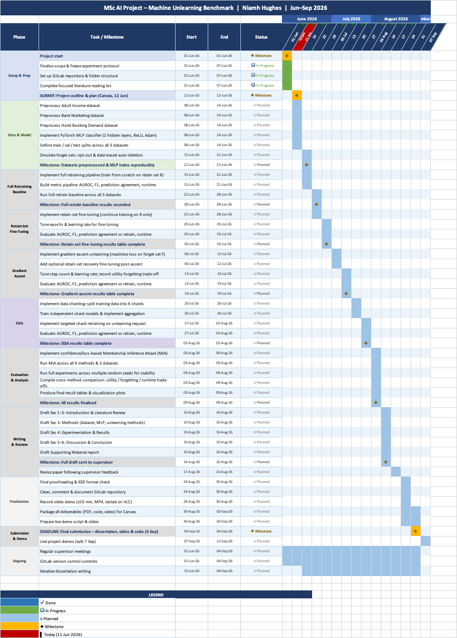
Appendix B: Gantt Chart

